Annex to the Order of the Director General
«Aviation administration of Kazakhstan» JSC
№0797ОД dated December 27, 2021

Temporary procedure for the recognition of the
foreign aircraft maintenance and repair organisations

1. Due to the current situation in the world on COVID-19, foreign aircraft maintenance and repair organizations (hereinafter referred to as “foreign organisations”), have the right to apply for the issuance or extension of the decision on recognition of the Certificate of foreign organisation (hereinafter referred to as “Decision on the recognition of the Certificate”).
2. This procedure applies to foreign organisations that intend to perform maintenance on aircraft included in the Civil Aircraft State Register of the Republic of Kazakhstan (hereinafter referred to as “RK”) and those foreign registered aircraft that are managed by the “Aviation Administration of Kazakhstan” JSC (hereinafter referred to as “AAK”) on behalf of a foreign civil aviation authority under the terms of an ICAO Article 83bis agreement. Foreign organisations are allowed to perform maintenance on the aircraft only after Decision on the recognition of the Certificate is issued by the AAK.
3. The procedure for recognition of the Certificates of foreign organisations applies to foreign organizations, provided that the requirements in accordance with which the Certificate is issued comply with the requirements and standards of ICAO and the certification requirements in force in the RK.
4. The recognition of the Certificate of a foreign organisation shall be carried out as per the declared scope of work of a foreign organisation (Terms of Approval).
5. Decisions on the recognition of the Certificate of the foreign organisations shall be issued for a period of not more than 35 calendar days.
6. AAK reserves the right to renew or suspend previously issued Decisions on the recognition of the Certificate of foreign organisation.
7. The authorised representative of the applicant shall submit a scanned copy of a complete Application form as per the Appendix 1 to this procedure with official letter to the AAK email address frontoffice@caakz.com. The following documents shall be provided with the application in electronic format:
a) confirmation letter from the civil aircraft operator (owner) of the RK;
b) copy of the valid Certificate of a foreign organisation;
c) scope of work of the Certificate of a foreign organisation (Terms of Approval);
d) Maintenance Organisation Exposition (MOE);
e) manpower plan confirming that the organisation has sufficient staff to plan, execute, manage production and control the quality of work in the organisation in accordance with its scope of work;
f) annual audit plan and audit reports (internal, external) including corrective actions of the foreign organisation’s Quality Assurance (Compliance Monitoring) Department;
g) the last certification (audit) report of a foreign organisation issued by the National Civil Aviation Authority;
h) Decision on the recognition of the Certificate of a foreign organisation previously issued by an aviation authority of the RK (if any);
i) audit report from civil aircraft operator (owner) of the RK on the audit of a foreign organisation;
j) additional data, information and materials requested by AAK.
All items specified in a) - j) are provided in PDF format with assignment of numbering and name of the document according to the above items.
8. The grounds for refusal to issue or extend Decision on the recognition of the Certificate:
a) establishing the inaccuracy of the documents submitted by the applicant for obtaining the Decision on the recognition of the Certificate, and (or) the data (information) contained in them;
b) non-compliance of the applicant and (or) submitted materials, objects, data and information necessary for issuing the Decision on the recognition of the Certificate.
9. The Aviation Inspector of the Airworthiness Department should verify the validity of the Certificate of a foreign organisation issued by the National Civil Aviation Authority that certified the subject organisation. Based on the results of the desktop assessment of the provided documents, an internal report on the verification of the documentation is drawn up by an Aviation Inspector, indicating the conclusions and recommendations regarding the application.
10. After passing internal approval by the AAK management personnel, a letter is sent to the authorised representative of the applicant by an official e-mail, to notify if the application was accepted or rejected. Decision on the recognition of the Certificate will be issued as per Appendix 2 of this procedure. Rejection will be provided in the form of an official letter.
11. The AAK reserves the right to perform an onsite inspection of the foreign organisations that have been issued with Decision on the recognition of the Certificate as per this temporary procedure.
12. The desktop assessment must not exceed 10 (ten) business days from the date of receipt of the application in the AAK. In cases where it is necessary to conduct additional review or verification by the Aviation Inspector of the Airworthiness Department, the desktop assessment period may be extended for the period of not more than 5 (five) business days.

Appendix 1

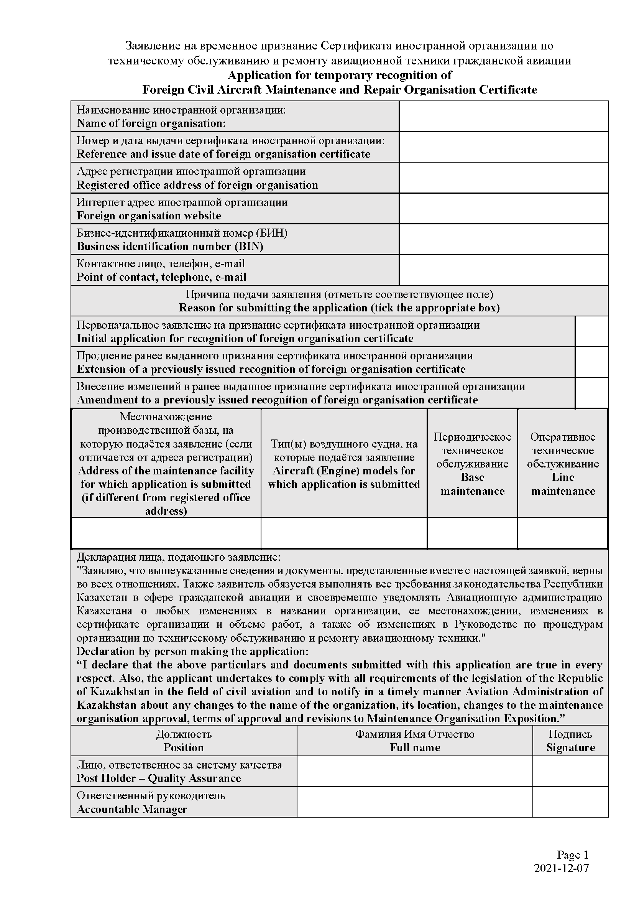

Appendix 2

