LETTERHEAD OF THE LEGAL ENTITY
Aviation Administration of Kazakhstan JSC
Application
for Issuance of an Opinion on the Impact of an Object / Activity
on the Safety of Aircraft Flights

1. Name of the Legal Entity (Individual) / Surname, Name, Patronymic (if any) of the Applicant:
For a legal entity:
Name of the legal entity: ____________________________________
Business Identification Number (BIN): __________________________________
Registered address of the company: _____________________________________
For an individual:
Full name:__________________________________________________________
Individual Identification Number (IIN): ___________________________________
Actual place of residence of the individual: ________________________________
2. Please issue an opinion for the activity, construction, installation, placement, expansion, reconstruction, technical re-equipment (underline as applicable) of the object(s):

(Indicate the object / list of objects or type of activity)
3. Purpose of the construction (reconstruction) object, description of the activity, location (place) indicating the region, district, reference to the settlement, distance from the Aerodrome Reference Point (ARP):
List of objects: _______________________________________________
Purpose of the object: ______________________________________________
Length of the object (for linear objects), m: ___________________
Description of the activity: ____________________________________________
Location (place) indicating the related settlement:
Region, district, rural district (if applicable), settlement, street, building / land plot / site: ________________________________________________
Cadastral number (if available): ____________________________________
Distance from the Aerodrome Reference Point (ARP), km: ___________________
- List of submitted information and/or documents attached to the Application in accordance with paragraph 12 and 15 of the Rules for Issuing Permits for Activities That May Pose a Threat to Aircraft Flight Safety, approved by the Resolution of the Government of the Republic of Kazakhstan dated May 12, 2011 No. 504.

- Position (if any), surname, name, patronymic of the applicant ______________________________________________________________________________________
(for legal entities, indicate position, surname, name, patronymic)

Signature/Date __________________________________________________
(Legal entities submit an application for a permit on the letterhead of the organization signed by the chief executive officer with a seal)

Attached documents
Object location data in the horizontal plane within the WGS–84 coordinate system:
Summary Statement of Object Coordinates
Table 1
№ | Point number (name) | Coordinates* |  | Coordinate accuracy, m
№ | Point number (name) | Latitude | Longitude | Coordinate accuracy, m
1
2
3
4
*Note: coordinates in seconds shall be to at least 2 decimal places

Prepared by (executor):
____________________________________________________________________________________________________________________________________
(state the name of the legal entity or the full name of the individual who performed the measurements, BIN/IIN, date of issue and number of the license for "Surveying activities", and the signature of the responsible official (individual), equipment used).

Date of the statement: "___" ________ 2026.

Object location data in the vertical plane: the object's own height and the terrain elevation at its location relative to Mean Sea Level (MSL), or the elevation of the highest point of the object above Mean Sea Level (MSL) within the WGS–84 system:
Summary Statement of Object Elevations and Terrain
Table 2
№ | Object | Height |  | Elevation accuracy, m
№ | Object | Object's own height (relative height from ground level to the highest point of the object), m | Terrain elevation at its location (absolute height relative to Mean Sea Level), m | Elevation accuracy, m
1
*Note: Elevations to at least 2 decimal places.

Prepared by (executor):
____________________________________________________________________________________________________________________________________
(state the name of the legal entity or the full name of the individual who performed the measurements, BIN/IIN, date of issue and number of the license for "Surveying activities", and the signature of the responsible official (individual), equipment used).

Date of the statement: "___" ________ 2026.

Maps showing the facility construction site referenced to a city or settlement, indicating the distance from the facility to the ARP (for facilities located within the aerodrome territory):
The map must display the names of settlements.
Example: Almaty city
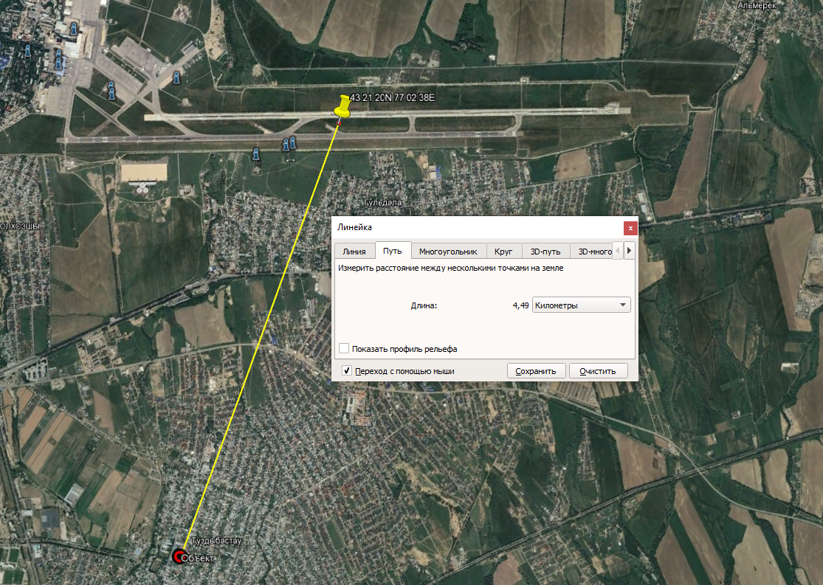
КТА
Distance from ARP
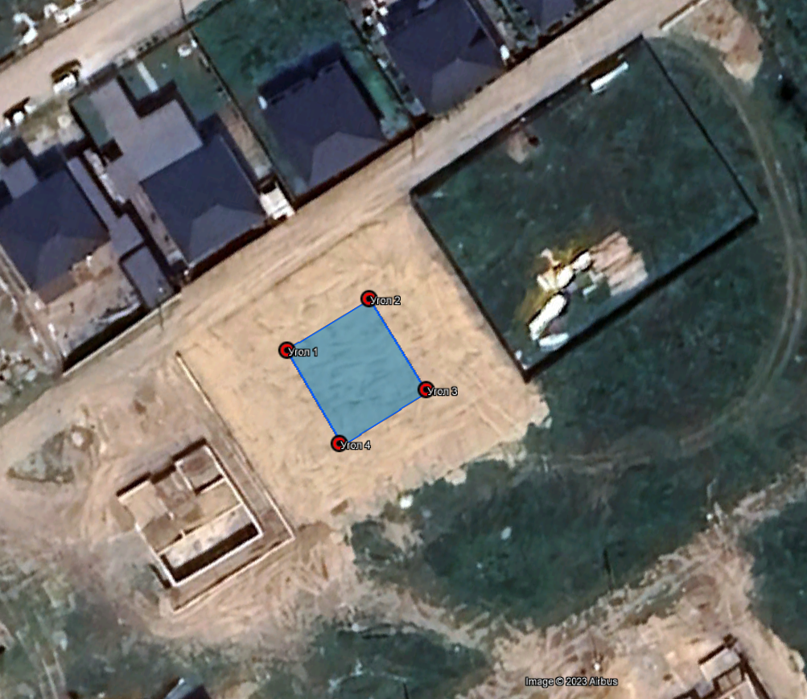

For power lines

Summary Statement of Coordinates and Elevations of Power Line Objects
Table 3
№ пп | Point number (name) | Coordinates * |  | Coordinate accuracy, m | Height |  | Elevation accuracy, m | Distance to ARP
№ пп | Point number (name) | Latitude | Longitude | Coordinate accuracy, m | Object's own height (relative height from ground level to the highest point of the object), m | Terrain elevation at its location (absolute height relative to Mean Sea Level), m | Elevation accuracy, m | Distance to ARP
*Note: coordinates in seconds shall be to at least 2 decimal places
Note: Elevations to at least 2 decimal places.

Prepared by (executor):
____________________________________________________________________________________________________________________________________
(state the name of the legal entity or the full name of the individual who performed the measurements, BIN/IIN, date of issue and number of the license for "Surveying activities", and the signature of the responsible official (individual), equipment used).

Date of the statement: "___" ________ 2026.

Power transmission line route plan incorporating terrain topography, oriented to the cardinal directions, indicating the scale and absolute ground surface elevations in the WGS–84 system:
- The plan shall be executed in the WGS–84 coordinate system.
- Absolute elevations on the TL (Transmission Line) route plan shall be specified in the WGS–84 Mean Sea Level (MSL) vertical datum (geoid).
- All transmission line towers (poles) shall be plotted on the plan in accordance with Summary Table 3 "Summary Register of Coordinates and Elevations of Transmission Line Facilities".
- Transmission line towers on the route plan shall be labeled in accordance with Summary Table 3 "Summary Register of Coordinates and Elevations of Transmission Line Facilities".
- The map border layout (marginalia) shall specify the compiler and the reviewer of the "Route Plan", including their signatures and dates.

Data on the purpose of radio-emitting devices, operating frequencies, emission bandwidth, modulation type, power, radiation directivity and antenna beamwidth, and antenna mounting heights:
Summary Register of Coordinates and Elevations

Table 4
№ | Object Name | Type of Radio-Emitting Device | Operating Frequencies | Emission Bandwidth | Modulation Type | Power, Watts | Radiation Directivity (Horizontal and Vertical Planes) | Radiation Pattern Beamwidth | Antenna Mounting Heights

Prepared by (executor):
____________________________________________________________________________________________________________________________________
(state the name of the legal entity or the full name of the individual who performed the measurements, BIN/IIN, date of issue and number of the license for "Surveying activities", and the signature of the responsible official (individual), equipment used).

Date of the statement: "___" ________ 2026.

For the placement of facilities leading to mass gatherings of birds or degradation of flight visibility:
- Data on the facility location;
- Type of activity and proposed mitigation measures to reduce the attractiveness of the activity to birds and other wildlife;
(to be specified in Section 2 of the application)
For example:
- MSW (Municipal Solid Waste) – elimination (или: MSW – remediation/closure)
- Farm – livestock fattening facility – closed type, no open access to feed, utilization of bird deterrents (bioacoustic devices, gas cannons).
- Agricultural fields – exclusion of grain crop cultivation, used for vegetable farming, field plowing conducted at night, utilization of bird deterrents (bioacoustic devices, gas cannons).

For other activities:
Information on the procedure and conditions for conducting other activities not directly related to the movement of material objects in airspace but affecting the safety of aircraft operations, their equipment, and persons on board:
For example:
- Flare stacks (systems) for emergency flaring of waste gases (when determining the height of flare systems, the maximum potential flame height shall be taken into account);
- Explosive facilities (или: facilities posing an explosion hazard);
- Facilities or activities leading to the degradation of flight visibility (due to smoke or other obscuration screens).

